* Express Routing executes the routing from top to bottom, so the order of the routing is very important. For example, Express supports dynamic routing, for example

This would be wrong, since the routers are parsed from top to bottom, it will find the productid as a dynamic route and it will consider delete as a variable as well;

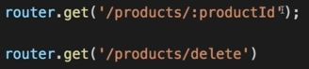

So the correct way is as below, if router finds the delete path, it will execute it , else it will move down and treat it as variable.

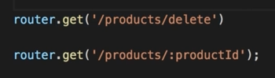

* Accessing the variable in the controller, 